Name: | Class: |  | Date Due:
Topic 3.1: Contextualizing Period 3 |  | Learning Objective: Explain the context in which America gained independence and developed a sense of national identity.

Periodization is used by historians and refers to the process of categorizing the past into discrete, quantified named blocks of time in order to facilitate the study and analysis of history. After reading topic 3.1, complete the following chart.

Ending Year for Period 3: | Definition of WHAT happened (or events leading up to that year): | Significance of year in history of the U.S./Why would historians choose this date as an ending point?

Name: | Class: |  | Date Due:
Topic 3.2: The Seven Years’ War |  | Learning Objective: Explain the causes and effects of the Seven Years’ War (the French and Indian War).

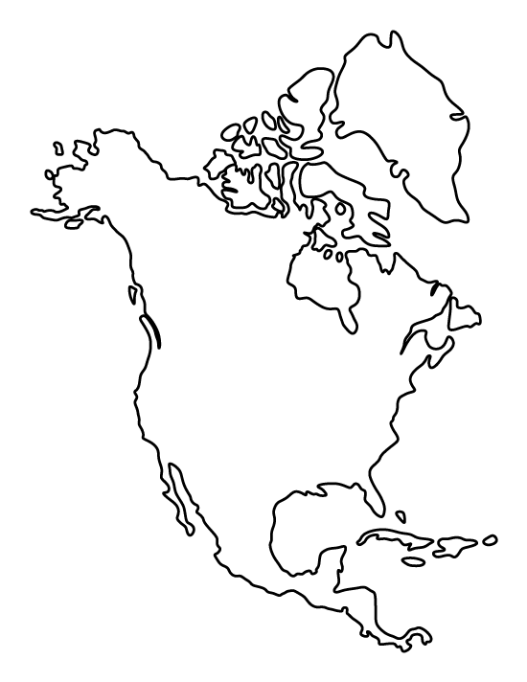
In different COLORS/SHADES, locate and identify territory lost by the French and Spanish as a result of the French and Indian War. Please also draw the Proclamation Line of 1763.

Key:
[ ] Lost by Spanish
[ ] Lost by French
[ ] Site of Pontiac’s Rebellion
[ ] Proclamation Line of 1763

Short Answer Response: Be sure to use the ACE strategy in responding to the question.
- Identify and explain ONE perspective the British had about colonial involvement in the war. ________________________________________________________________________________________________________________________________________________________________________________________________________________________________________________________________________________________________________________________________________________
- Identify and explain ONE perspective the colonists had about colonial involvement in the war. ________________________________________________________________________________________________________________________________________________________________________________________________________________________________________________________________________________________________________________________________________________
- Identify and explain ONE impact the differing viewpoints cited in a and b will have on the relationship between the British and colonists. ________________________________________________________________________________________________________________________________________________________________________________________________________________________________________________________________________________________________________________________________________________

Name: | Class: |  | Date Due:
Topic 3.3: Taxation without Representation |  | Learning Objective: Explain how British colonial policies regarding North America led to the Revolutionary War.

After reading, complete the chart below:
Event | Definition & Type of Tax: | Colonial Response:
Stamp Act:

Townshend Act:

Tea Act:

“The parliament unquestionably possesses a legal authority to regulate the trade of Great Britain, and all her colonies. Such an authority is essential to the relation between a mother country and her colonies; and necessary for the common good of all. He who considers these provinces as states distinct from the British Empire, has very slender notions of justice, or of their interests. We are but parts of a whole… till the Stamp Act administration. All before, are calculated to regulate trade, and preserve or promote a mutually beneficial intercourse between the several constituent parts of the empire; and though many of them imposed duties on trade, yet those duties were always imposed with design to restrain the commerce of one part, that was injurious to another, and thus to promote the general welfare.. Never did the British parliament, till the period above mentioned, think of imposing duties in America for the purpose of raising a revenue.” – John Dickinson, Letters from a Farmer in Pennsylvania, 1768

Use the excerpt above to answer the following questions:

- The concerns expressed by Dickinson were a response to
  - Dispute over the growing French population along the borders
  - Controversy between a majority Patriot movement against loyalists
  - Extended contact with Native Americans and Africans
  - Increased attempts of the British to assert authority over colonies
- Which of the following groups would have supported Dickinson’s point of view in the excerpt?
  - Royal governors in Virginia
  - Wealthy merchants from New York and Philadelphia
  - Colonial laborers and artisans
  - Planters in the southern colonies

Name: | Class: |  | Date Due:
Topic 3.4: Philosophical Foundations of the American Revolution |  | Learning Objective: Explain how and why colonial attitudes about government and the individual changed in the years leading up to the American Revolution.

Historians have varying arguments concerning the development of revolutionary thinking that led to the American Revolution. For this section, you’ll need to apply information from previous chapters/periods.

Short Answer Response: Be sure to use the ACE strategy in responding to the question.
- Identify and explain ONE example of how early colonists had developed “enlightened” government principles in early colonial governments. ________________________________________________________________________________________________________________________________________________________________________________________________________________________________________________________________________________________________________________________________________________
- Identify and explain ANOTHER example of how early colonists had developed “enlightened” government principles in early colonial governments ________________________________________________________________________________________________________________________________________________________________________________________________________________________________________________________________________________________________________________________________________________
- Identify and explain ONE impact the Enlightenment had on thinking as represented in Thomas Paine’s Common Sense. ________________________________________________________________________________________________________________________________________________________________________________________________________________________________________________________________________________________________________________________________________________

Name: | Class: |  | Date Due:
Topic 3.5: The American Revolution |  | Learning Objective: Explain how various factors contributed to the American victory in the Revolution.

Many individuals inaccurately claim that colonists desired independence from the early years of frustration and increased taxation. The events leading to the First Continental Congress prove that this is not accurate. Using the information gained from the chapter, complete the diagram below by identifying and briefly describing the steps the colonists took to reconcile with the British prior to the official Declaration of Independence in 1776.

Name: | Class: |  | Date Due:
Topic 3.6: Influence of Revolutionary Ideals |  | Learning Objective 1: Explain the various ways the American Revolution affected society.  Learning Objective 2: Describe the global impact of the American Revolution.

Using information from the chapter, look at the political cartoon below and complete the following:
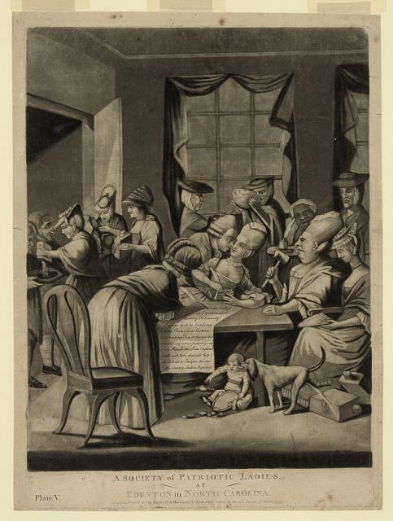
Title: A society of patriotic ladies, at Edenton in North Carolina
Creator(s): Robert Sayer and John Bennett (Firm),
Summary: Print shows satire of American women from Edenton, North Carolina, pledging to boycott English tea in response to Continental Congress resolution in 1774 to boycott English goods.

Short Answer Response: Be sure to use the ACE strategy in responding to the question.
- Briefly explain ONE perspective expressed by the artist about women’s role in society preceding and during the American Revolution. ________________________________________________________________________________________________________________________________________________________________________________________________________________________________________________________________________________________________________________________________________________
- Briefly explain how ONE event or development led to the historical situation depicted in the image. ________________________________________________________________________________________________________________________________________________________________________________________________________________________________________________________________________________________________________________________________________________
- Briefly explain ONE specific outcome that resulted from women’s contributions in the American Revolution. ________________________________________________________________________________________________________________________________________________________________________________________________________________________________________________________________________________________________________________________________________________

Name: | Class: |  | Date Due:
Topic 3.7: The Articles of Confederation |  | Learning Objective: Explain how different forms of government developed and changed as a result of the Revolutionary Period.

Name: | Class: |  | Date Due:
Topic 3.8: The Constitutional Convention and Debates over Ratification |  | Learning Objective: Explain the differing ideological positions on the structure and function of the federal government.

Short Answer Response: Be sure to use the ACE strategy in responding to the question.
- Identify and explain ONE similarity the new Constitution held to state constitutions developed amidst the Revolution. ________________________________________________________________________________________________________________________________________________________________________________________________________________________________________________________________________________________________________________________________________________
- Identify and explain ONE compromise the new Constitution passed at the Convention. ________________________________________________________________________________________________________________________________________________________________________________________________________________________________________________________________________________________________________________________________________________
- Identify and explain ONE specific criticism brought forth by the anti-Federalists concerning the power of the new federal government. ________________________________________________________________________________________________________________________________________________________________________________________________________________________________________________________________________________________________________________________________________________

Name: | Class: |  | Date Due:
Topic 3.9: The Constitution |  | Learning Objective: Explain the continuities and changes in the structure and functions of the government with the ratification of the Constitution.

Complete the following chart:
Amendment | Description of Amendment | How was it a response to British action? Can write N/A if necessary
First
Second
Third
Fourth
Fifth
Sixth
Seventh
Eighth
Ninth
Tenth

Name: | Class: |  | Date Due:
Topic 3.10: Shaping a New Republic |  | Learning Objective 1: Explain how and why competition intensified conflict among peoples and nations from 1754 to 1800.  Learning Objective 2: Explain how and why political ideas, institutions, and party systems developed and changed in the new republic.

After reading, complete the chart below by identifying FIVE significant events discussed in the chapter. These events are your choice but use key concept sheet for reference.
Event | Description | Key Concept Citation | How did it shape American identity?

“Observe good faith and justice towards all nations; cultivate peace and harmony with all… Antipathy in one nation against another disposes each more readily to offer insult and injury, to lay hold of slight causes of umbrage, and to be haughty and intractable, when accidental or trifling occasions of dispute occur... So likewise, a passionate attachment of one nation for another produces a variety of evils. Sympathy for the favorite nation, facilitating the illusion of an imaginary common interest in cases where no real common interest exists…Against the insidious wiles of foreign influence (I conjure you to believe me, fellow-citizens) the jealousy of a free people ought to be constantly awake, since history and experience prove that foreign influence is one of the most baneful foes of republican government…” – George Washington, Farewell Address, 1796

In writing a DBQ, you will need to “source” at least four documents effectively. Practice document sourcing by using Washington’s Address above and the sentence stems below.
Intended Audience:
- Because this is a ___________________ and likely to be read by _______________________________, it makes sense that (the author – name the person) would say ___________________________ because….
Purpose of Document:
- The purpose of this document is _________________, so it makes sense that the author would (present/say/communicate) ____________ because…..
Historical Context:
- This document was written during _______________________ (time period/event/movement), which would have impacted (the writing of this document, the way the author viewed this event, the ideas in the document) in the following way….
Authors Point of View (POV)
- (The author) would likely emphasize _______________________________________________because he/she is a ______________________________. (Make sure to explain why _________________s/he would feel this way and how it would impact the argument)

Choose TWO of the above and “source” Washington’s Farewell Address.
______________________________________________________________________________________________________________________________________________________________________________________________________________________________________________________________________________
______________________________________________________________________________________________________________________________________________________________________________________________________________________________________________________________________________

Name: | Class: |  | Date Due:
Topic 3.11: Developing an American Identity |  | Learning Objective: Explain the continuities and changes in American culture from 1754 to 1800.

Preparation for a THESIS statement. Remember a thesis is your main argument and for most long essay questions (LEQs) you will want to have three points of argument. Your thesis should only be 1-2 clear, concise sentences. With an extent question, you should be identifying how MUCH or how LITTLE something was impacted (i.e. significant, moderate, limited, etc.)

Thesis Formula: X, However, a, b, c. Therefore, y. X = Counterargument/Counterpoint A, B, C = Categories of Analysis Y = Argument
Evaluate the extent to which early Republican government formed a unique, American identity.
______________________________________________________________________________________________________________________________________________________________________________________________________________________________________________________________________________
Name: | Class: |  | Date Due:
Topic 3.12: Movement in the Early Republic |  | Learning Objective 1: Explain how and why migration and immigration to and within North America caused competition and conflict over time.  Learning Objective 2: Explain the continuities and changes in regional attitudes about slavery as it expanded from 1754 to 1800.

Short Answer Response: Be sure to use the ACE strategy in responding to the question.
- Identify and explain ONE way in which migration in the early republic impacted indigenous populations. ________________________________________________________________________________________________________________________________________________________________________________________________________________________________________________________________________________________________________________________________________________
- Identify and explain ONE way in which migration in the early republic impacted African Americans. ________________________________________________________________________________________________________________________________________________________________________________________________________________________________________________________________________________________________________________________________________________
- Identify and explain ONE way in which migration from Europe to the early republic altered regional economic developments. ________________________________________________________________________________________________________________________________________________________________________________________________________________________________________________________________________________________________________________________________________________

