Name: | Class: |  | Date Due:
Topic 2.1: Contextualizing Period 2 |  | Learning Objective: Explain the context for the colonization of North America from 1607 to 1754.

Periodization is used by historians and refers to the process of categorizing the past into discrete, quantified named blocks of time in order to facilitate the study and analysis of history. After reading topic 2.1, complete the following chart.

Ending Year for Period 2: | Definition of WHAT happened (or events leading up to that year): | Significance of year in history of the U.S./Why would historians choose this date as an ending point?

Name: | Class: |  | Date Due:
Topic 2.2: European Colonization in North America |  | Learning Objective: Explain how and why various European colonies developed and expanded from 1607 to 1754.

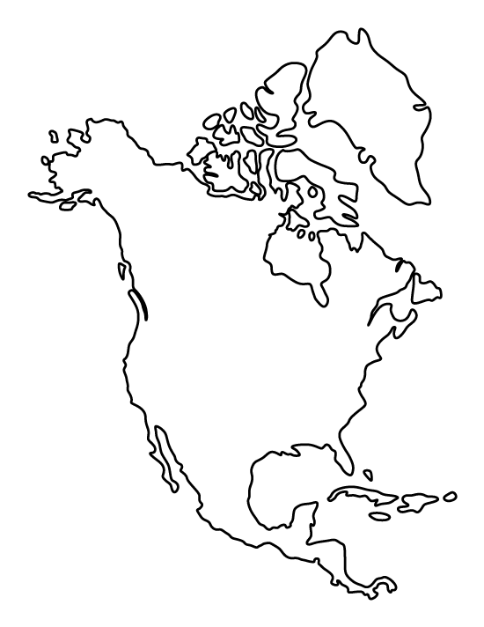
In different COLORS/SHADES, locate and identify by shading/coloring where the Europeans settled in North America.

Key:
[ ] Spanish
[ ] French
[ ] Dutch
[ ] English

Short Answer Response: Be sure to use the ACE strategy in responding to the question.
- Identify and explain ONE way the Spanish interacted with indigenous peoples during settlement of the Americas. ________________________________________________________________________________________________________________________________________________________________________________________________________________________________________________________________________________________________________________________________________________
- Identify and explain ONE way another European country interacted with indigenous peoples during the settlement of the Americas. ________________________________________________________________________________________________________________________________________________________________________________________________________________________________________________________________________________________________________________________________________________
- Identify and explain ONE reason for the difference in treatment of indigenous peoples cited in responses a and b. ________________________________________________________________________________________________________________________________________________________________________________________________________________________________________________________________________________________________________________________________________________

Name: | Class: |  | Date Due:
Topic 2.3: The Regions of British Colonies |  | Learning Objective: Explain how and why environmental and other factors shaped the development and expansion of various British colonies that developed and expanded from 1607 to 1754.

After reading, complete the chart below:
Event | Colonies within Region | Motives for Settling:
New England:

Middle:

Southern & Chesapeake:

Preparation for a THESIS statement. Remember a thesis is your main argument and for most long essay questions (LEQs) you will want to have three points of argument. Your thesis should only be 1-2 clear, concise sentences. With an extent question, you should be identifying how MUCH or how LITTLE something was impacted (i.e. significant, moderate, limited, etc.)

Thesis Formula: X, However, a, b, c. Therefore, y. X = Counterargument/Counterpoint A, B, C = Categories of Analysis Y = Argument
Evaluate the extent to which early British colonies reflected democratic ideas in the period leading to 1754.
______________________________________________________________________________________________________________________________________________________________________________________________________________________________________________________________________________
Name: | Class: |  | Date Due:
Topic 2.4: Transatlantic Trade |  | Learning Objective: Explain the causes and effects of transatlantic trade over time.

Complete the chart below based on information from the text:

Name: | Class: |  | Date Due:
Topic 2.5: Interactions between American Indians and Europeans |  | Learning Objective: Explain how and why interactions between various European nations and American Indians changed over time.

Short Answer Response: Be sure to use the ACE strategy in responding to the question.
- Identify and explain ONE conflict that emerged between the Spanish and indigenous populations in the Americas. ________________________________________________________________________________________________________________________________________________________________________________________________________________________________________________________________________________________________________________________________________________
- Identify and explain ONE conflict that emerged between the English and indigenous populations in the Americas. ________________________________________________________________________________________________________________________________________________________________________________________________________________________________________________________________________________________________________________________________________________
- Identify and explain ONE way the response of the Spanish to the impact of the conflict was different from the response of the English to the impact of the conflict. ________________________________________________________________________________________________________________________________________________________________________________________________________________________________________________________________________________________________________________________________________________

Name: | Class: |  | Date Due:
Topic 2.6: Slavery in the British Colonies |  | Learning Objective 1: Explain the causes and effects of slavery in the various British colonial regions.  Learning Objective 2: Explain how enslaved people responded to slavery.

Short Answer Response: Be sure to use the ACE strategy in responding to the question.
- Identify and explain ONE characteristic of slavery that emerged in English colonies in 1619. ________________________________________________________________________________________________________________________________________________________________________________________________________________________________________________________________________________________________________________________________________________
- Identify and explain ONE characteristic of slavery that developed in English colonies in the 18th century. ________________________________________________________________________________________________________________________________________________________________________________________________________________________________________________________________________________________________________________________________________________
- Identify and explain ONE reason for the different characteristics of slavery from 1619 to the 18th century in English colonies. ________________________________________________________________________________________________________________________________________________________________________________________________________________________________________________________________________________________________________________________________________________

Name: | Class: |  | Date Due:
Topic 2.7: Colonial Society and Culture |  | Learning Objective 1: Explain how and why the movement of a variety of people and ideas across the Atlantic contributed to the development of American culture over time.  Learning Objective 2: Explain how and why the different goals and interests of European leaders and colonists affected how they viewed themselves and their relationship with Britain.

Short Answer Response: Be sure to use the ACE strategy in responding to the question.
- Identify and explain ONE characteristic of the Great Awakening that began in the 1730s. ________________________________________________________________________________________________________________________________________________________________________________________________________________________________________________________________________________________________________________________________________________
- Identify and explain ONE religious impact of the Great Awakening that began in the 1730s. ________________________________________________________________________________________________________________________________________________________________________________________________________________________________________________________________________________________________________________________________________________
- Identify and explain ONE political impact of the Great Awakening that began in the 1730s. ________________________________________________________________________________________________________________________________________________________________________________________________________________________________________________________________________________________________________________________________________________
Complete the following chart:
Individual/Achievement: | Phillis Wheatley | Benjamin Franklin | John Peter Zenger
Impact of Individual in Colonial Culture/Society:
Is this impact a separation or continuation of “English” culture? Provide evidence for support.

Preparation for a THESIS statement. Remember a thesis is your main argument and for most long essay questions (LEQs) you will want to have three points of argument. Your thesis should only be 1-2 clear, concise sentences. With an extent question, you should be identifying how MUCH or how LITTLE something was impacted (i.e. significant, moderate, limited, etc.) You may want to use the chart above for guidance as well.

Thesis Formula: X, However, a, b, c. Therefore, y. X = Counterargument/Counterpoint A, B, C = Categories of Analysis Y = Argument
Evaluate the extent to which British colonists developed their own identity in the 18th century.
______________________________________________________________________________________________________________________________________________________________________________________________________________________________________________________________________________

