Name: | Class: |  | Date Due:
Topic 1.1: Contextualizing Period 1 |  | Learning Objective: Explain the context for European encounters in the Americas from 1491 to 1607.

Periodization is used by historians and refers to the process of categorizing the past into discrete, quantified named blocks of time in order to facilitate the study and analysis of history. After reading topic 1.1, complete the following chart.

Starting Year for Period 1: | Definition of WHAT happened (or events leading up to that year): | Significance of year in history of the U.S./Why would historians choose this date as a starting point?

Ending Year for Period 1: | Definition of WHAT happened (or events leading up to that year): | Significance of year in history of the U.S./Why would historians choose this date as an ending point?

Name: | Class: |  | Date Due:
Topic 1.2: Native American Societies before European Contact |  | Learning Objective: Explain how various native populations interacted with the natural environment in North America in the period before European contact.

In different COLORS/SHADES, locate and identify by shading/coloring the various indigenous groups below, see page 5.
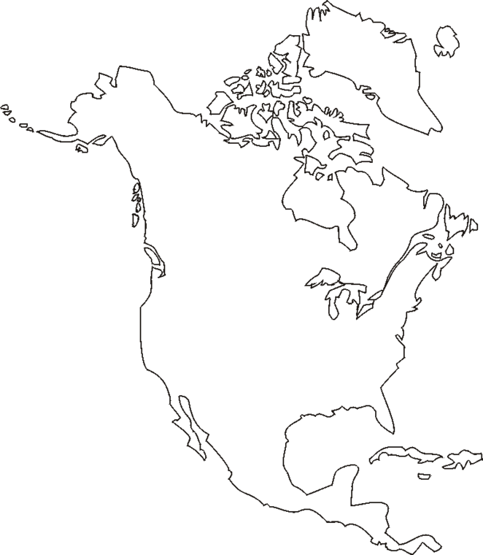
Key:
[ ] Arctic
[ ] Northwest Coast
[ ] California
[ ] Great Basin
[ ] Great Plains
[ ] Northeast
[ ] Southeast
[ ] Mesoamerica
[ ] Caribbean

Short Answer Response: Be sure to use the ACE strategy in responding to the question.
- Identify and explain ONE specific difference between the cultures of the indigenous peoples of the Northeast settlements and Great Basin/Great Plains settlements. ________________________________________________________________________________________________________________________________________________________________________________________________________________________________________________________________________________________________________________________________________________
- Identify and explain ONE specific similarity between the cultures of the indigenous peoples of the Northeast settlements and Great Basin/Great Plains settlements. ________________________________________________________________________________________________________________________________________________________________________________________________________________________________________________________________________________________________________________________________________________
- Identify and explain ONE reason for the difference cited in response A. ________________________________________________________________________________________________________________________________________________________________________________________________________________________________________________________________________________________________________________________________________________

Name: | Class: |  | Date Due:
Topic 1.3: European Exploration in the Americas |  | Learning Objective: Explain the causes of exploration and conquest of the New World by various western nations.

After reading, complete the chart below:
Event | Explanation of Event | How did this event cause European exploration?
Change of Thought/Renaissance:

Religious Conflict:

Muslim conquest of Constantinople:

Short Answer Response: Be sure to use the ACE strategy in responding to the question.
- Identify and explain ONE motive for exploration and colonization for the Spanish and/or Portuguese in the Americas. ________________________________________________________________________________________________________________________________________________________________________________________________________________________________________________________________________________________________________________________________________________

- Identify and explain an ADDITIONAL motive for exploration and colonization for the English in the Americas separate from the one used for the Spanish in part a. ________________________________________________________________________________________________________________________________________________________________________________________________________________________________________________________________________________________________________________________________________________
- Identify and explain ONE difference in the development of colonization between the Spanish and English in the Americas. ________________________________________________________________________________________________________________________________________________________________________________________________________________________________________________________________________________________________________________________________________________

Name: | Class: |  | Date Due:
Topic 1.4: Columbian Exchange, Spanish Exploration, and Conquest |  | Learning Objective: Explain causes of the Columbian Exchange and its effect on Europe and the Americas during the period after 1492.

Short Answer Response: Using the excerpts from page 18, answer a, b, and c. Be sure to use the ACE strategy in responding to the question.
- Briefly describe ONE important difference between Nunn and Qian’s and Lewis and Maslin’s historical interpretations of the Columbian Exchange.
________________________________________________________________________________________________________________________________________________________________________________________________________________________________________________________________________________________________________________________________________________
- Briefly explain how ONE specific historical event, development, or circumstance from the period of 1491-1607 that is not specifically mentioned in the excerpts could be used to support Nunn and Qian’s argument.
________________________________________________________________________________________________________________________________________________________________________________________________________________________________________________________________________________________________________________________________________________
- Briefly explain how ONE specific historical event, development, or circumstance from the period of 1491-1607 that is not specifically mentioned in the excerpts could be used to support Lewis and Maslin’s argument.
________________________________________________________________________________________________________________________________________________________________________________________________________________________________________________________________________________________________________________________________________________

Name: | Class: |  | Date Due:
Topic 1.5: Labor, Slavery, and Caste in the Spanish Colonial System  Topic 1.6: Cultural Interactions in the Americas |  | Learning Objective (1.5): Explain how the growth of the Spanish Empire in North America shaped the development of social and economic structures over time.  Learning Objective (1.6): Explain how and why European and Native American perspectives of others developed and changed in the period.

In the Venn diagram below, label one circle Spanish, one French, and one English and compare their relations with indigenous populations.

Preparation for a THESIS statement. Remember a thesis is your main argument and for most long essay questions (LEQs) you will want to have three points of argument. Your thesis should only be 1-2 clear, concise sentences. With an extent question, you should be identifying how MUCH or how LITTLE something was impacted (i.e. significant, moderate, limited, etc.)
Thesis Formula: X, However, a, b, c. Therefore, y. X = Counterargument/Counterpoint A, B, C = Categories of Analysis Y = Argument

Evaluate the extent to which forced labor servitude by Europeans changed African culture in the period of 1491 to 1607.
______________________________________________________________________________________________________________________________________________________________________________________________________________________________________________________________________________

